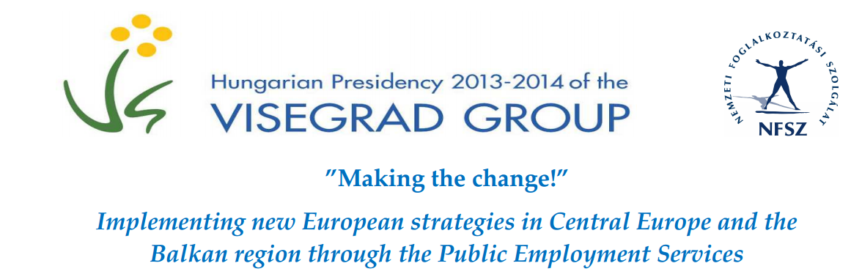

CONFERENCE REPORT
The 2-day conference hosted by the Hungarian National Labour Office took place in Budapest on the 25-26th February 2014. In his opening speech, Mr. Róbert Komáromi, the Director-General of the NLO expressed his intent that the conference was an event of professional knowledge-sharing as the V4 countries have a lot to learn from each other. He also presented the Hungarian circumstances regarding the two main topics of the first day: the Youth Guarantee scheme and the EURES reform. The other heads of PES of the V4 also introduced their state of affairs and agreed that while youth unemployment is indeed one of the gravest problems in Europe, it is important to extend the focus beyond the 15-24 age groups and handle the problems of other disadvantaged groups on the labour market. The key aspects to tackle youth unemployment is to try and influence the choice of professions in order to avoid young people entering the labour market with knowledge not demanded; and to facilitate gaining job experience as early as possible either in the form of dual training or job placements or even encouraging summer jobs. The Czech Republic reported a 60 per cent success rate in job placement programmes where young people either stay at the employer or receive a job offer straight away from other employers. Poland operates a voucher system to support the placement of young people and also involves the largest bank in providing a start-up loan of up to 25 000 Euros for youngster willing to set up their own businesses. Poland also revived the historical organisation of the Voluntary Labour Corps (OHP) that first provided support after World War I to young people having lost their parents in the war. Now this state organization aims at creating adequate conditions for proper social and vocational development of young people aged 15-25. The discussion touched upon the issue of NEET (neither-in-employment-nor-in-education-or-training) youth. In Slovakia this problem is being handled by the support of bottom-up community initiatives. With regard to the EURES reform, the discussion covered the approaches on how to involve private job-brokerage companies in EURES and the need to incorporate EURES operations in the ESF operational programmes. The importance of strong cooperation between the different sectors were emphasised throughout the discussion. The coordination of activities and the sharing of information between labour organisations; educational actors; municipalities and the representation of businesses like chambers of commerce is a vital part of PES operations.
On the second day, the V4 countries were joined by the representatives of the Centre for Public Employment Services of Southeast European Countries (CPESSEC). In his welcome address, Mr. Komáromi stressed the importance of this special composition after the signing of the Joint Statement of the Visegrad Group on the West-Balkans last October during the Meeting of the Ministers of Foreign Affairs of the Visegrad Group together with the West-Balkan counterparts. This conference was one of the first occasions that these countries can work together and share their knowledge with each other on a professional level.
The second day proceeded with three presentations on the part of the hosting organisation, introducing the main topics of the second part of the conference and raising questions for discussions in the workshops. Ms. Ignits laid the foundation by presenting the major labour market trends in the V4 countries with a brief outlook on the South-East European countries. The presentation covered the main demographic trends of the working age population and their consequences on the labour market; the macroeconomic environment; the employment characteristics of the V4 and SEE countries as well as the labour-market situation of youth and the key employment challenges.
The introductory presentation of Mr. Borbély-Pecze to the theme of workshop 1 outlined the main challenges of PES in matching future skills needs on the labour market. The skills mismatch is a burning issue not only in fighting youth unemployment but also in investing in human capital. With the exception of Poland and Estonia, the V4 and SEE countries are lagging behind in the PISA scores. However, when discussing investments into skills, it is important to bear in mind that they do not automatically turn into jobs but that nonetheless makes it a crucial element to social inclusion and long-term investment into people. This raises the question whether it is the responsibility of labour organisations or the educational system to improve skill levels. Undoubtedly, the employment organisations play a crucial role in dismantling barriers to the labour market by providing training opportunities; adequate labour-market intelligence; and facilitating the cooperation of concerned actors. With regard to labour-market prognosis the distinction was made between the longer-term workforce projection and the short-term labour market analysis, namely signalling. However, it remains a question whether PES can and should get involved in workforce projection when its core task is certainly the latter. The thought-provoking questions for the workshops concerned the definition of skills in the different national contexts and the definition of the nature of labour market training programmes; and the role of PES in providing labour market prognoses.
The introductory presentation of Mr. Kovács concerned the role of online systems in PES operations, the topic of Workshop 2. First, the currently available Hungarian systems were presented such as the online labour-market portal that currently has over 40.000 registered job-seekers and 16.000 job vacancies; and the life-long guidance portal that supports people of all ages to find the occupations that best suit their skills and interests. Mr. Kovács also reported on the ongoing portal integration process; and the intention to construct PES applications for mobiles. As PES portals have 15.000-20.000 unique visitors a day, they are undoubtedly an important part to PES operations. They support job-seekers with easy self-help access while at the same time bring down service delivery costs of PES. Even though the benefits of online systems are manifold, PES must also tackle problems of unreliable data entry by clients; and the loss of personal influence on clients. The question was also raised how to best exploit the potential of the social media.
After the presentations, the conference split up into two simultaneous workshops where participants could discuss the two main topics in greater details. At the end of the conference, the rapporteurs of each workshop summarised the content of their discussions and findings. Workshop I on the topic of skills, vocational training and labour-market intelligence included presentations from the representatives of Bulgaria and Serbia. The Bulgarian presentation on the forecasting of labour market needs of workforce skills drew the attention to the fact that the shortage of workers with the necessary skills along with the aging population is a major obstacle to economic growth and attracting of investments in Bulgaria. Therefore, it is crucial that the Employment Agency provides adequate training opportunities as well as improves its capabilities of forecasting labour market demands. The presentation described the ongoing construction of “National Unit of Forecasting the Development of the Labour Market in Bulgaria” implemented by the Ministry of Labour and Social Policy. The Serbian presentation on the forecasting of labour market trends and on the role of active policy measures described the methods and preliminary results of the National Employers Survey 2013 and the details of the National Employment Action Plan for 2014. The following discussion concluded that the PES should always have the main responsibility of providing labour-market prognosis but there is a strong need for continuous communication between sectors as well as different stakeholders. Currently these prognoses are mainly questionnaire based surveys that combine qualitative and quantitative approaches but only cover a short-term outlook of a maximum of one year. The provision of labour-market prognosis demands staff with highly specialised knowledge. PES must also look towards and learn from private providers such as Adecco. With regard to PES provision of trainings as part of the active labour-market measures, the participants agreed that in most countries the administration of public tendering can slow down the process of selecting adequate training organisations. Most countries provide trainings on the basis of a yearly plan and in member states these are generally financed by ESF. It would be ideal if employers would also take part in devising the curricula so that schools and training organisations are well aware of their needs.
Workshop II on the topic of online tools also included presentations from participating countries. The Slovakian example of the recently introduced online matching tool provided a perfect insight into how such a system can become the biggest pool of online vacancies within 3 months of its launch. The system is capable of exporting vacancies from employers’ IT systems and provides an easy access for employers to submit their job posts. On the basis of formal agreements, the system also uploads vacancies from private job-brokerage websites. Jobseekers registered with the employment office automatically have a profile that they can activate on the website and indicate their perceived competences. They can also define online “job agents” for a set of criteria that searches vacancies of their interests. The matching system compares the data provided by the jobseekers and the employers and provides a percentage of how good the match is or what skills are missing for the applicant. The system also evaluates the client in an “e-profiling” function and enables employers to access profiles without posting vacancies. It also includes a register of professions with descriptions, wage levels and required skills. Within the 3-month pilot phase, the system attracted 3.000 employers who posted 12.000 vacancies and 42.000 out of the 400.000 jobseekers activated their profiles. This resulted in a decreased number of employers registering in person with the local labour offices. The system is not yet connected to the EURES portal. Croatia also has a “labour exchange” system with 100.000 users. The Croatian representative also presented their career guidance software that is aimed at facilitating young people’s career choices. A regular survey on the intentions of pupils in primary and secondary education shows that 60% of students require support for their career decisions. Croatia is planning to launch an “e-counselling” project that will be a one-stop-shop for information and counselling services on education, training, and the labour-market. Serbia also presented its online career guidance service system that targets mainly elementary school leavers. With regard to social media, most PES have Facebook accounts (Croatia with 11.000 followers, Turkey with 50.000 followers) and some make use of Twitter as well. The participants agreed that experiences with the social media are generally quite positive. The solutions presented and discussed in the workshops were relatively similar and most countries faced the same challenges. It was an important conclusion though that self-help tools only support and supplement but does not substitute personal contacts.
In the last plenary session all participants had the chance to listen to the rapporteurs reports on the workshop. The representative of the ILO in his concluding remarks welcomed and stressed the importance of such active, knowledge-sharing occasions in the topics of employment and drew the attention to the dateless truth in the ILO’s 1944 Declaration of Philadelphia that states that “labour is a resource and not a commodity”.

